# An introduction to Optitrack Motion Capture

## Gentle introduction

Motion capture is a discipline that consists of capturing elements in a 3D space and reconstructing the space virtually from such elements. Optitrack is frequently used in research in order to localize a object precisely without an internal localization mechanism.

### 

*There are various motives for tracking real bodies, from research, to enabling a robot to localize itself, and animators even use animation for more realistic character movement (see God of War 4).* My particular application uses position estimation for drone control. The position and orientation of each body is streamed into the ROS framework over the local network.

**Optical motion capture** uses reflective trackers coupled with infrared sensors. The tracking elements or trackers are small reflective balls. A camera pointed towards the tracker outputs infrared light via its LED illumination ring. The lens at the center of the ring capture any and all IR incoming light.

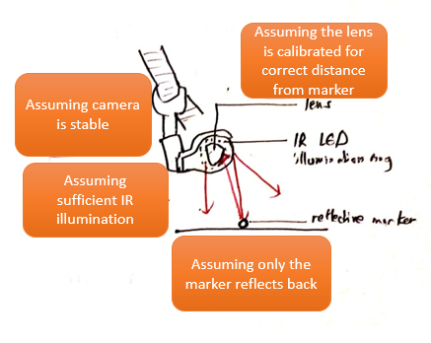

This tutorial will be split in 3 orders of difficulty depending on your needs. Beginners who wish to use the setup unsupervised should look into Section x: Quick start guide. Precision-dependant scenarios (e.g. drone control via its position) will make use of Section x: Precision capture theory. Finally, the long-term users might be interested in simplifying maintenance and capture processes with Section x: Streamlining.  
 **Areas of application**

While the motion-capture system creates a single point of failure, we chose it over alternatives due to its high performance: typical position errors are less than one millimeter. In comparison, a state-of-the-art decentralized localization system using ultra-wideband radio triangulation showed position errors of over 10 centimeters, too large for dense formations. While vision-based methods are both accurate and decentralized, the required cameras and computers necessitate a much larger vehicle.

### Areas of application

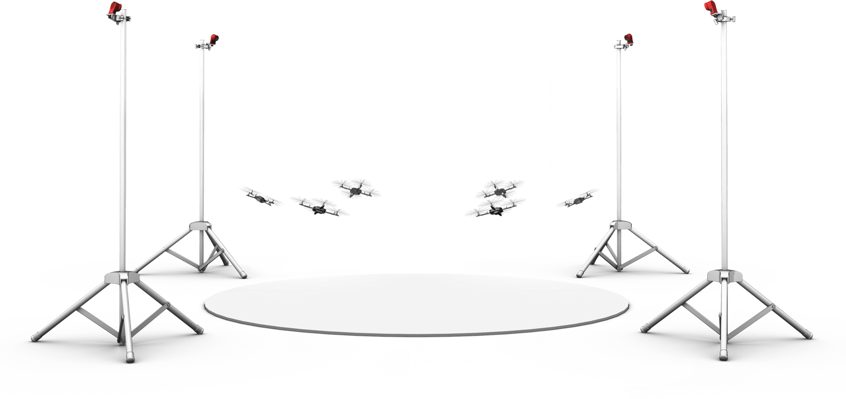

While the motion-capture system creates a single point of failure, we chose it over alternatives due to its high performance: typical position errors are less than one millimeter. In comparison, a state-of-the-art decentralized localization system using ultra-wideband radio triangulation showed position errors of over 10 centimeters, too large for dense formations. While vision-based methods are both accurate and decentralized, the required cameras and computers necessitate a much larger vehicle.

### Overview

Optitrack is a company that offers its own motion capture setup. The hardware setup and the software solution are both available as a package purchase. Using the setup is a multi-step process:

* With the system set up, tracker data is sampled through a process called calibration. Calibration essentially is about computing the relative positions of the cameras. Once calibrated, we expect the cameras to localize trackers accurately.
* Precision capture theory: during operation, the system relies on reflected IR rays, so naturally we will examine the capture arena to capture light rays better.
* Going further, the software component has multiple parameters to work around a poor calibration or to deal with limitations inherent to this technology. This is where I explore camera controls, marker ray management, pre-processing etc.

To use the Optitrack motion capture system, you will find information in these places.

* the online docs are very approachable. There is also a series of Youtube tutorial videos. However, be aware that these documents are deprecated at times, nevertheless they offer an overview of the technology as a whole ie. Optical motion capture.
* a gentle introduction to Motive (the PC software): interfacing with the cameras (covered), editing 3D reconstructions for optimisation (not covered), more functionality is available.
* The customer support is fast (under a day).

## Quick start guide

This quickstart explains how to install the equipment and perform a first-hand calibration of the capture area. If all the components are at hand, the **hardware setup** typically takes 20 minutes, followed by 5-10 minutes of **calibration** depending on the quality desired. Once a **rigid body is defined**, its captured position estimates can be **streamed on the local network**, either live or through a recording.

*Using wifi has streaming latencies of under 20ms which is sufficient for our purposes.*

### Hardware Setup

We will cover checking that the hardware is available in the lab (list of hardware below), then a basic setup with a few tricks for optimising the system performance, a calibration with an active wand.

Make sure you have a PC running Windows (or Mac? Motive 2.2.0 software is not available for Linux). To run Motive, you need to insert the hardware key and generate the online license within Motive software.

DVIC Note: Please ask other members for activation codes.

The basic setup is laid out diagrammatically as such. Note the use of a proprietary USB cable for camera to Optihub (extension cords are not recognised), and the use of a Data Cable for Optihub to PC.

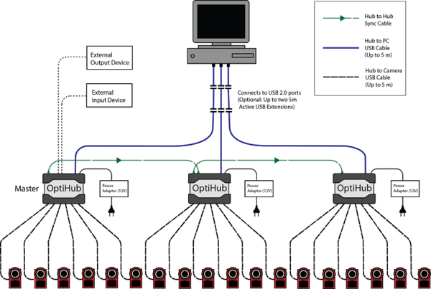

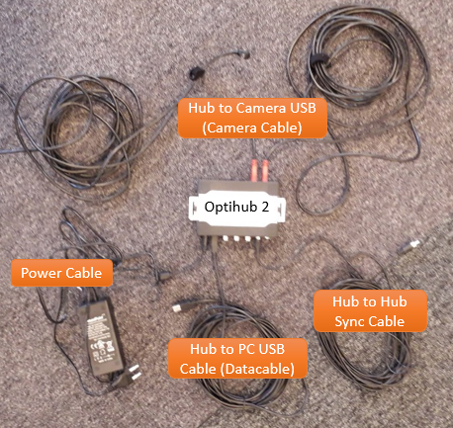

*Optihub wiring*

DVIC Note: Since extension cords are not recognised between camera and Optihub, larger setups will require two Optihubs, connected to eachother via a master-slave cable (master port: hub in).

DVIC Note 2: With 2 Optihubs, 2 Data Cables will feed back to the PC. For best performance, connect the USB port to the PC on two different USB controllers (regarding latency issues).

* That hardware key (USB)
* 4 Flex 13 cameras,
* Vicegrips and rotating stands for the cameras
* 100% stable zones to attach cameras (DVIC: consult the group before attaching to the ceiling)
* USB (cables?),
* 2 Optihub V2,
* 2 Data cables,
* 2 USB Extension cords
* Active calibration wand CWA-500 (DVIC: ask the members concerned)
* A minimum of 3 trackers per object (it’s apparently possible to do with less trackers)

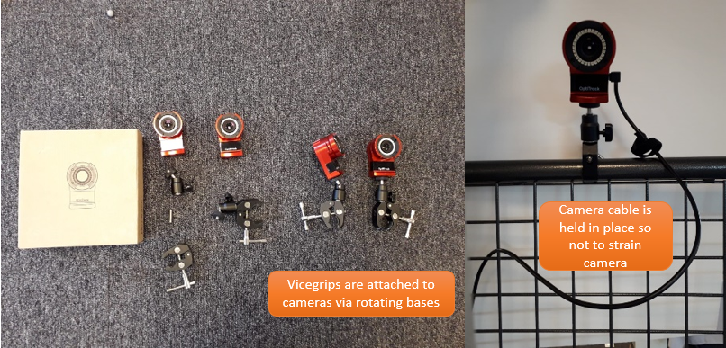

*Assembling the cameras*

### Component setup

To avoid doing hundreds of setups like I have, try choose your space carefully. A **darker non-reflective floor** and a **consistent level of illumination** might turn out useful to contrast markers effectively. The question is also whether to have a close-up configuration, or to span larger volumes. After all, motion capture usually takes place in large warehouses as such.

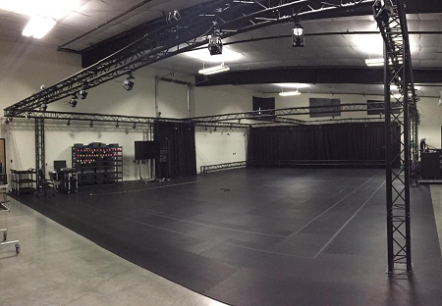

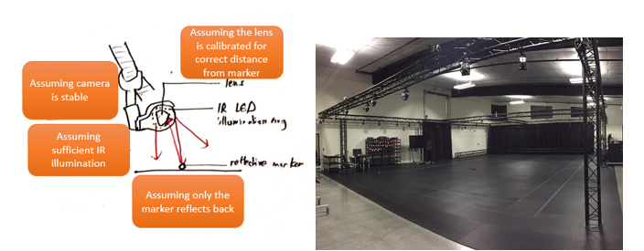

With 4 cameras, the classic configuration is as such.



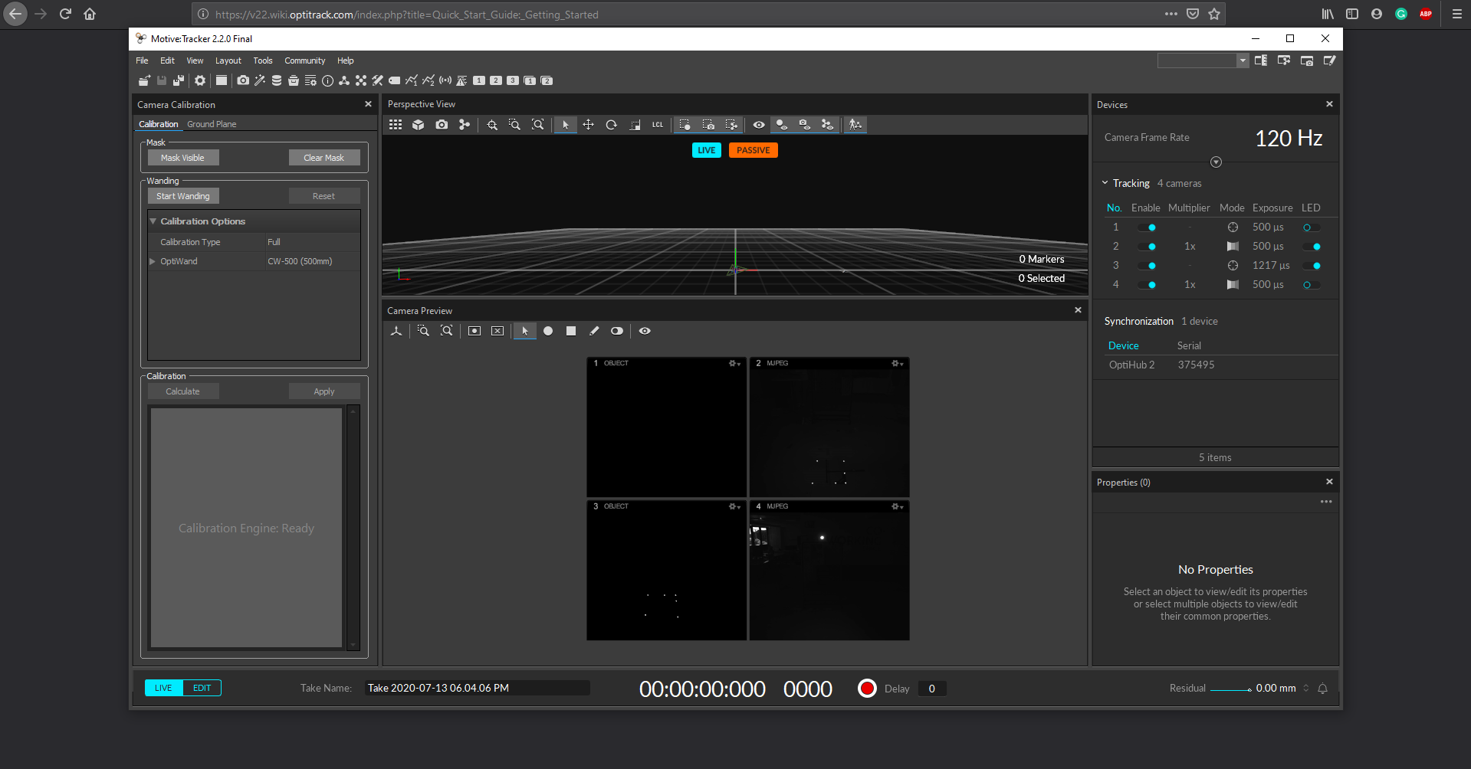

*Using camera modes to check for extraneous reflections*

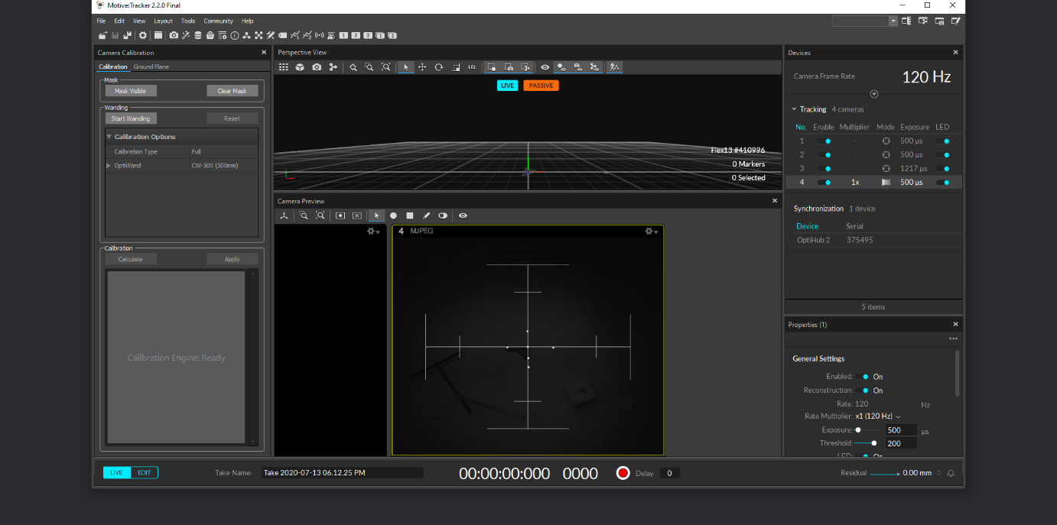

*Aiming the camera using the Grayscale option*

### What to look out for in a calibration

An “excellent” or “exceptional” calibration, as OT labels them, will have submillimetre accuracy to localize the position of trackers. This becomes desired when the OT system is affected by high latency. This occurs in high speed applications (e.g. racing drone) but more importantly applications with multiple bodies (e.g. drone swarming), or on a PC running other applications (e.g. wifi signal intensity for drone control might slow down PC processes).

Now that a case has been made for calibration quality, to actually improve a calibration, we need to inspect the main problem areas during calibration:

* Space management for best results
* Making sure all cameras are properly configured at a certain range
* The wanding process during calibration
* An introduction to postprocessing

### Wanding: data collection

At its simplest, the data samples are collected by waving a 3-marker stick all across the motion capture arena. There are two types of wands: active calibration wands output IR light, while passive wands have reflective markers. Beyond that, the mechanical design of the wand reveals all potential hiccups through the wanding process.

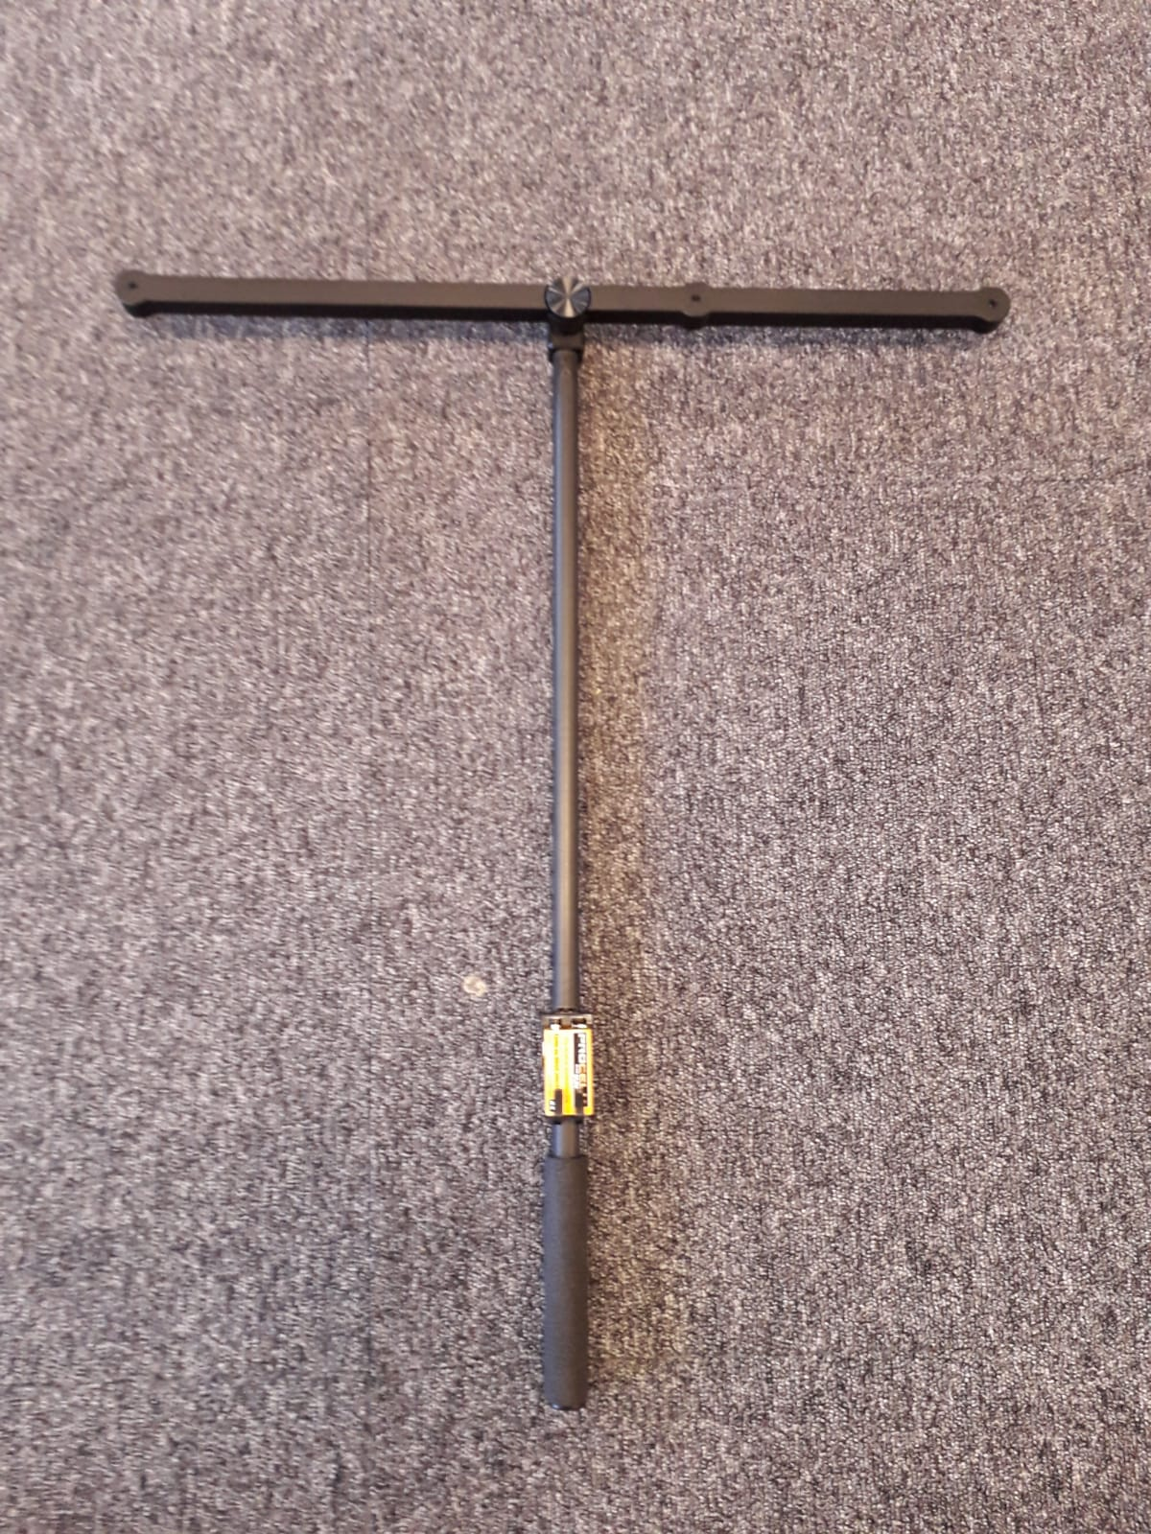

DVIC Note: constructing such a wand is not to be taken lightly, as the marginal error in the marker positions has a large effect on the calibration results, as such.

DVIC Note 2: there is no online documentation to use active wands – instead the Optitrack helpdesk has outlined the process as below.

To activate the wand, assemble it carefully and insert the provided battery. Select the Calibration Wand model CW-500 (the passive version of our CWA-500) and turn off LED illumination on the cameras as such. This greatly reduces the chance of reflection. The desired result is as such.

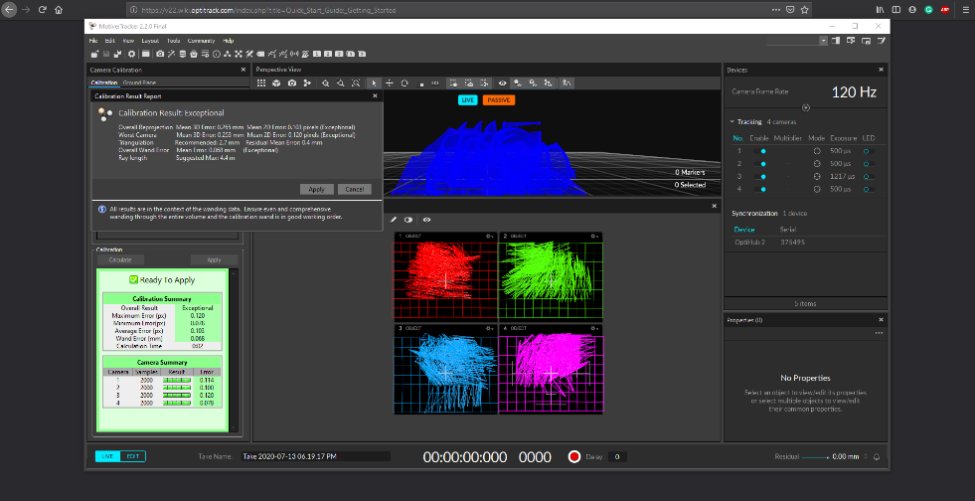

It is possible to go a step further and edit a take for better calibration. Badly positioned markers can be removed from the sample data.

Finally, calibrations degrade over time. It can be as simple as a slipping camera, or a sudden vibration reaching the camera. But as the system heats up, the lens themselves are affected by thermal deformation. The simplest solution to this is to calibrate after the system has heated up (it is advised to wait about an hour). Temperature fluctuations and other environment conditions can have an effect. Feel free to re-calibrate regularly, and alternatively to have cameras calibrate during a recording (***see more***).

### The rigid body function

This can be defined directly from the Perspective View as such.

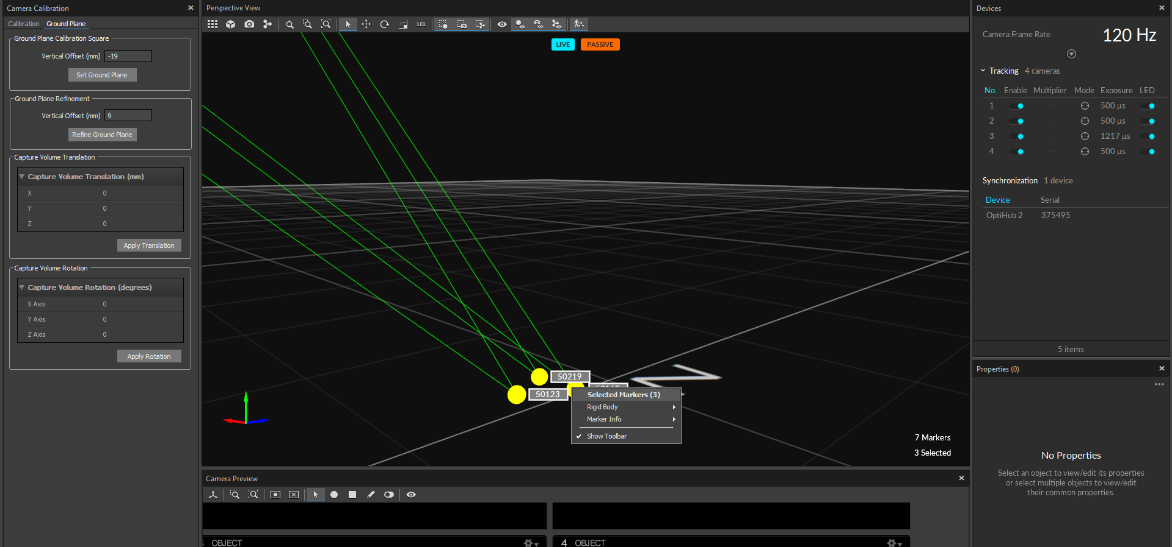

Position and orientation information can be graphed as such.

### Data streaming

This is automatically streamed as such.

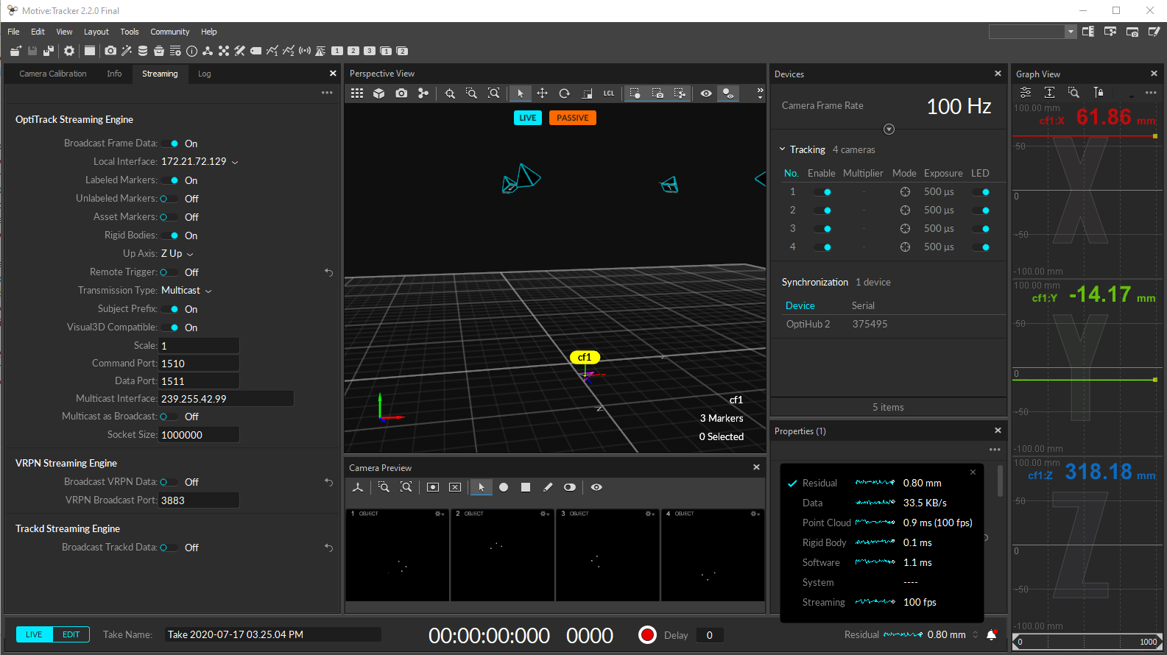

I have successfully managed to receive such information onto ROS via two separate protocols: VRPN (Virtual Reality Protocol Network?) and NatNet SDK.